JZoomer User Guidance V1.0
by Marquis Hou<talent_marquis>
marquisx.tz@gmail.com

1. Screen Shots
1.1 Main frame
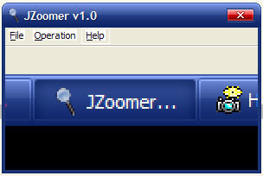
1.2 About dialog
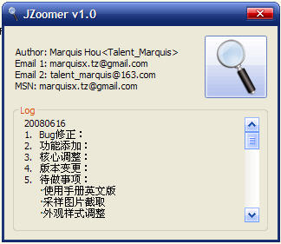
1.3 Tray
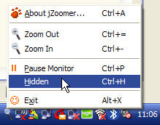

2. Function
2.1 Hot keys
Function | Hot key | Description
Zoom out | Ctrl+=, mouse scroll(up) | Max zoom rate: 8x
Zoom in | Ctrl+-, mouse scroll(down) | Min zoom rate: 1x
Start/Pause | Ctrl+P | Start/Pause zoom sample
Hidden | Ctrl+H | Hidden mainframe into tray
Exit | Alt+X | Exit JZoomer

2.2 Configuration: system.properties
#jZoomer info
author = Marquis Hou //author
version = v1.0 //version
#jZoomer init
init.width = 300 //initializing window width
init.height = 200 //initializing window height
min.width = 200 //minimum window width
min.height = 150 //maximum window height
zoom.rate.max = 8 //maximum zoom rate
zoom.rate.min = 1 //minimum zoom rate
zoom.rate.default = 2 //default zoom rate
capture.millisecond = 50 //monitor sample frenquency(毫秒)
on_top = true //always on top
#The locale of jZoomer
#now you can choose two locales: zh_CN and en_US
support.locale = en_US,zh_CN //supported language
locale = zh_CN //current language

Note: if you want to swith language, just change the parameter of locale from en_US to zh_CN.

